Class: EE3501

Assignment: Lab 1

Professor: Craig A. Chin

Student: Goran Novakovic

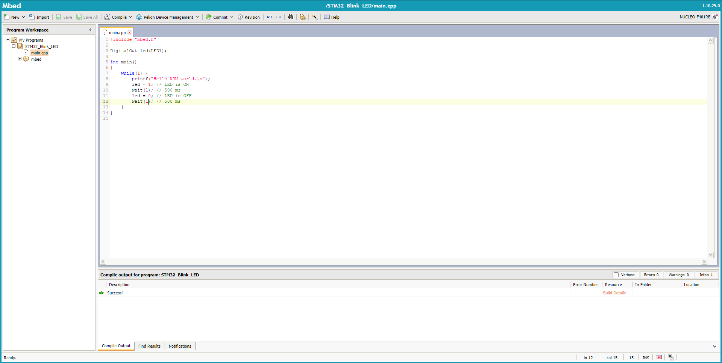

Figure 1: Mbed IDE interface with C code.

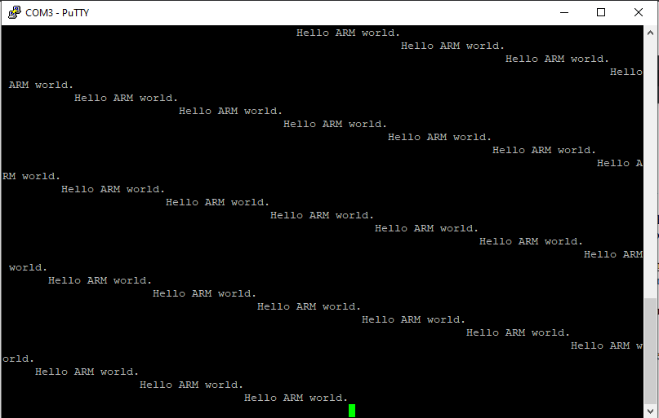

Figure 2: PuTTy COM3 serial port reading (Hello world code)

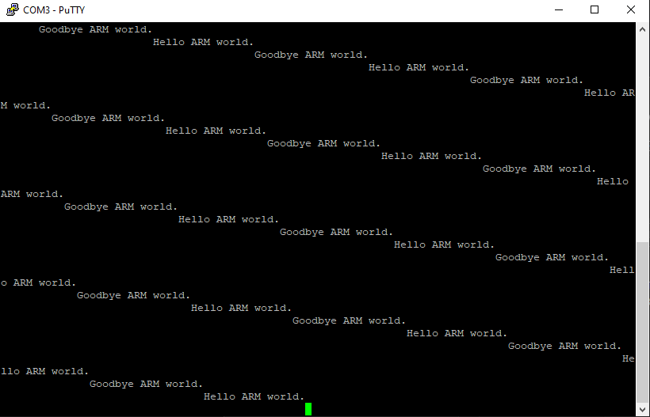Figure 3: PuTTy COM3 serial port reading (Goodbye code)

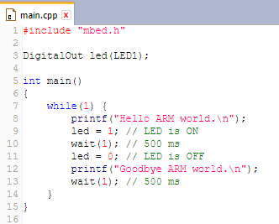

Figure 4: Goodbye code in C

Changing the board or components that the compiler is coding for is as easy as clicking at the board name and selecting the platform as shown in figures 5 and 6.

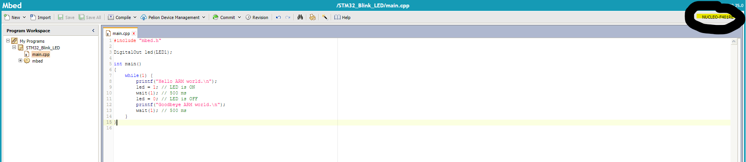

Figure 5: Top right corner selection of the components

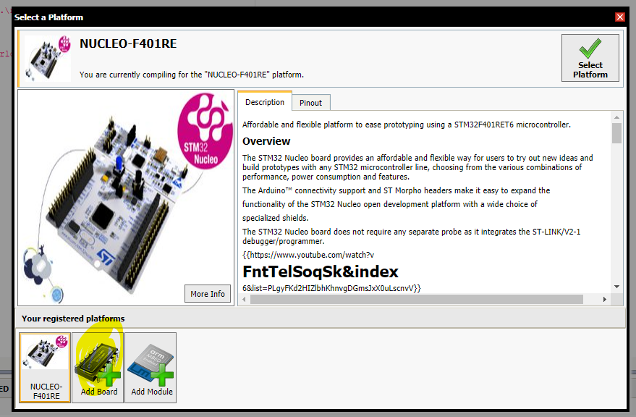

Figure 6: Add board and pick a new board then click the Select Platform